Games Production

Shenkuu Warrior Remake
Game Concept
Revised Draft
10/6/10

NeoPets Inc., an MTV Networks Company



2. Shenkuu Warrior Redo

2.1 Introduction

Shenkuu Warrior swings back into action in a sequel! Now, we find the littlest princess exploring new terrain and traveling different routes as she grapples her way up the mountain. Navigating land and air while avoiding falling rocks, she’ll arm herself with a variety of tools and power ups during her training to become a warrior princess.

2.2 Why This Game

Shenkuu Warrior is a challenging, fast-paced platformer with an intriguing and popular game mechanic. The original game has difficult controls, and is very hard to play. The core mechanic of the grappling hook presents a strong jumping off place for a fun, twitchy sequel to the game.

2.3 Proposal for Game Features

We will create a ground up remake with new art, and game engine with an eye on staying consistent w/ the current game mechanic conventions.

The following updates are planned:

- Incorporate power-ups & obstacles
    - a Tangram Kite power-up hovers on the stage with light animation, but no vertical movement. Player treats the kite as they would a ledge, but grappling the kite and being propelled as if the kite is a rocket boost in Doodle Jump game example. Princess grapples the kite and then it hangs from the kite vertically by her grapple rope.

    - A flying petpet provides a temporary boost. This power-up is positioned on the ledge and the princess should either collide with or grapple the petpet to activate the power-up.

    - Platforms/Ledges suddenly disintegrate –
            - Disintegrating ledges should be indicated by art
            - A hit by the grapple will cause the ledges to disintegrate but small pieces are left over which the player must now quickly navigate through to regain top speed lost.
            - Eventually by last level in Top of Mountain mode, ledge disintegrates on impact causing loss of momentum.
            - Code knows to provide recovery ledges once a ledge disintegrates

    - Possible idea: power-up which keeps the ledges from disintegrating for period of time

    - Possible idea: a vine sprouts via action by the player and princess can grapple up from any point on the vine

- Improved game control & physics – The current game provides very little directional control for the player. Where you aim with the mouse is not consistent with the trajectory or final point of the grappling hooks path.

    - Incorporate better up/down physics so that there can be a variance in top speed and bottom speed. See illustration.
    - Grappling hook control should allow for the princess to come in fairly close proximity to the target of where her hook landed. Animation should show that the rope gets a little shorter as the princess is slung upward, but the players momentum will likely make this animation very quick. Just want to get the sense that the princess/player has some control of the hook.

- Variety of grapples through level progression
    - Similar to unlocked bats in Kass Basher, each level unlocks new more powerful grappling hook.

- Better level progression tied to a story
    - Top of Mountain Mode – Each of the 3 levels that make up mountain mode have finite distances to achieve.
      - Each level unlocks a new hook, contains a multiplier (to be determined and tested) to increase difficulty.
      - Level 1 is a grassy mountain terrain
      - Level 2 is a rocky mountain terrain
      - Level 3 is an icy mountain terrain
Endless Mode
unlocked once player successfully completes Top of Mountain mode. This is an infinite level where player goes for points. This level would be

- Cut scenes between levels (tbd)
    - Cut-scene between each unlocked level should be very short to not interrupt the flow of the game.

- Art

    - New background art for mountain terrain – grassy, rocky, icy, and possible cloud level .
    - Update to the princess. Give her new clothes?
    - Intro screen
    - Logo
    - Trophies
    - Game User-Interface
    - NGC prizes – AAA, Abigail, Lulu
    - Ledges (various sizes, colors for disintegrating ledges)
    - Winged Petpets (2-3)
    - Tangram Kites (minimum of 3)
    - 3 unique grappling hooks
    - 3 cut-scenes

    - Allow for variety of 2-3 petpets, 2-3 different looking kites to be stored and used in levels to create some variation in the look of each level.

2.4 Key Features/Fixes
A - List
- Slower vertical scrolling
- Improved physics
- Obstacle AI – disintegrating ledges
- Better directional control of grappling hook
- Fast-paced repeatable gameplay
- Unlockable levels – Top of Mountain & Endless Mode
- Updated story
- Power-ups
- Overhaul scoring based solely on distance (for Top of Mountain mode). Example: 1800 meters = 1800 points multiplied by NP ratio = score
B – List
- Enviornmental obstacles – down draft, up draft, weather variances
- Time-based scoring
- Vine spawn

2.5 Look and Feel

Game References:

Doodle Jump

Twitchy platformer for IPhone

http://www.youtube.com/watch?v=LNRzC5ZGr4Q

Jetpack Jackass – Example of adding twist on the grappling hook mechanic by introducing booster/floating power up. Also, disintegrating ledges, and falling objects.

http://games.adultswim.com/jetpack-jackass-twitchy-online-game.html

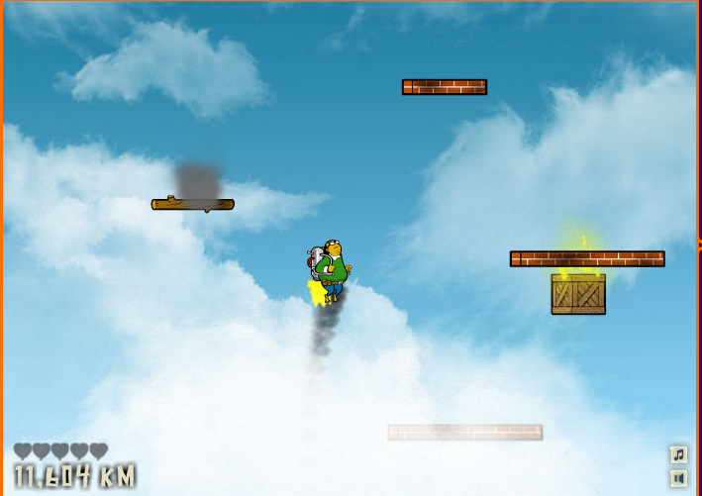

3.0 Specs
Game dimensions: 650x600

More details to be provided by Viv & Dave

